HTML ID

Table of content

* What is HTML ID attribute?
* What is a use of id attribute?
* Is class and Id Attribute same?
* How to create HTML Id in JavaScript?

What is HTML ID attribute?

HTML ID is a concept of representing the unique id element in the document. Id attribute is use by CSS and JavaScript.

Generally Id attribute is use in division for calling div function in document. This id attribute can be represented by # symbol along with name of the Id attribute.

In HTML5 there is no restriction of id attribute you can use it in any element but while using HTML4.01 id attribute will not support to all the elements in the document.

Syntax-

<Style>

#name-of-id {

Property: value

}

<html tag id=”name of id”></html end tag>

</style>

Example-

<!DOCTYPE html>

<html lang="en">

  <head>

    <title>Document</title>

  </head>

  <style>

    #idname {

      text-align: center;

      font-size: xx-large;

      font-weight: 500;

      font-family: "Segoe UI", Tahoma, Geneva, Verdana, sans-serif;

      text-transform: uppercase;

      color: #000;

      background-color: blanchedalmond;

    }

  </style>

  <body>

    <div id="idname">Geeky4u.com</div>

  </body>

</html>

Output-



What is a use of Id attribute?

In HTML document, id attribute is use for pointing to the unique specification of a style-sheet. Id attribute is use and call by unique HTML element.

With the JavaScript Id attribute is use for manipulating the style-sheet and use for making the very exciting changes in the style-sheet.

**Syntax-**

<start tag id=”idname”></ end tag>

**Example-**

<!DOCTYPE html>

<html lang="en">

  <head>

    <title>Document</title>

  </head>

  <style>

    #idname {

      background-color: turquoise;

      text-align: center;

      text width: 30px;

      letter-spacing: 1cm;

      font-size: xx-large;

      font-weight: 500;

      color: #000;

    }

  </style>

  <body>

    <div id="idname">Example of ID attribute</div>

  </body>

</html>

Output-



Similarly, id attribute is also use for linking the specific element which may be in the top or may be in the bottom.

If you are on the bottom of the webpage and the content of the webpage is very large and you wish to navigate from bottom to top then id attribute help to create a link through which you can able to navigate within the webpage.

Example-

<!DOCTYPE html>

<html>

  <body>

    <h1>Example of Id-</h1>

    <h2><a id="top">Document 1</a></h2>

    <h3>Paragraph starts here--</h3>

    <p>

      content of my paragraph<br />

      content of my paragraph<br />

    </p>

    <img src="techno image.jfif" height="500px" width="600px" /><br />

    <a href="#top" style="font-size: xx-large">Go on top</a>

  </body>

</html>

Output- This is an output when you click on go on top then the webpage will directly navigate on the top the top of the webpage.



Is class and Id Attribute same?

Class and Id attribute both may be work in the same way but both the class and id are different.

Id attribute is applicable only up to the unique element and also call by the unique element in the document.

Class can be applied more than one or on all the elements in the document.

Class can be define (.) along with the class name.

Id can be define (#) along with the class name.

Example-

<!DOCTYPE html>

<html lang="en">

  <head>

    <meta charset="UTF-8" />

    <meta name="viewport" content="width=device-width, initial-scale=1.0" />

    <title>Document</title>

  </head>

  <style>

    #idname {

      background-color: cornsilk;

      text-align: center;

      font-size: xx-large;

      font-weight: 500;

      color: rgb(20, 14, 14);

    }

    .classname {

      color: #0b325a;

      background-color: #dcdedf;

    }

  </style>

  <body>

    <h1 id="idname">Example of Id attribute------element with unique id</h1>

    <h1 class="classname">Example of class</h1>

    <h1 class="classname">class can be call within all html elements</h1>

    <h1 class="classname">multiple element call by same class</h1>

  </body>

</html>

Output-

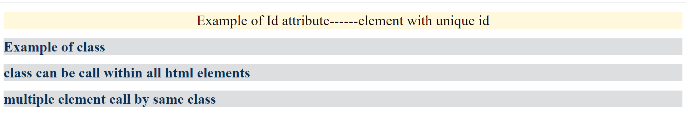

How to create HTML Id in JavaScript?

The use of Id attribute is very interesting in JavaScript If user wish to make any changes by using Id attribute then JavaScript will allow.

For this it is important to declare id attribute in head section and then declare the JavaScript Function In the body section at the same time it is important to call id attribute in the function to see the changes.

**Example-**

<!DOCTYPE html>

<html lang="en">

  <head>

    <meta charset="UTF-8" />

    <meta name="viewport" content="width=device-width, initial-scale=1.0" />

    <title>Javascript example</title>

    <style>

      #idname {

        background-color: rgb(206, 197, 201);

        text-align: center;

        font-size: xx-large;

        font-weight: 500;

        color: rgb(20, 14, 14);

      }

    </style>

  </head>

  <body>

    <h1 id="idname">Welcome</h1>

    <button onclick="FirstResult()">click here</button>

    <script>

      function FirstResult() {

        document.getElementById("idname").innerHTML = "Geeky4u.com";

      }

    </script>

  </body>

</html>

**Output-**

-First you will get below output.



-After this, if you click on click here button then you will get below output.

